Day 3

Q. 1 try to create a playbook in which

Install software testqwerty . if installs successful then show a msg installation successful otherwise installation failed

Start the service testqwerty , if start failed then show a msg service start failed if successful then show msg service started

If both fails then show a msg “Playbook was unsuccessful”

Display the stored output as well.

Ans.

Vim register.yml

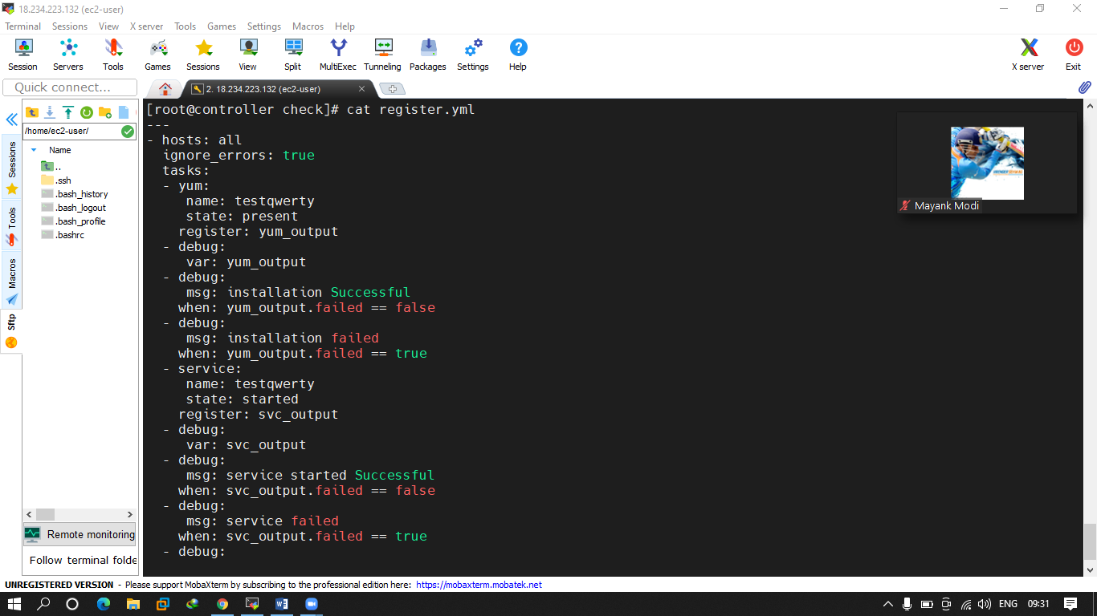

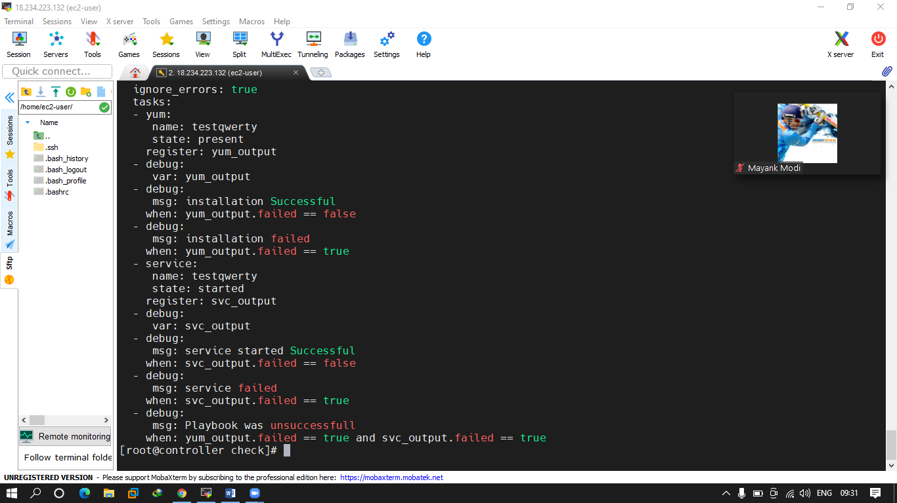

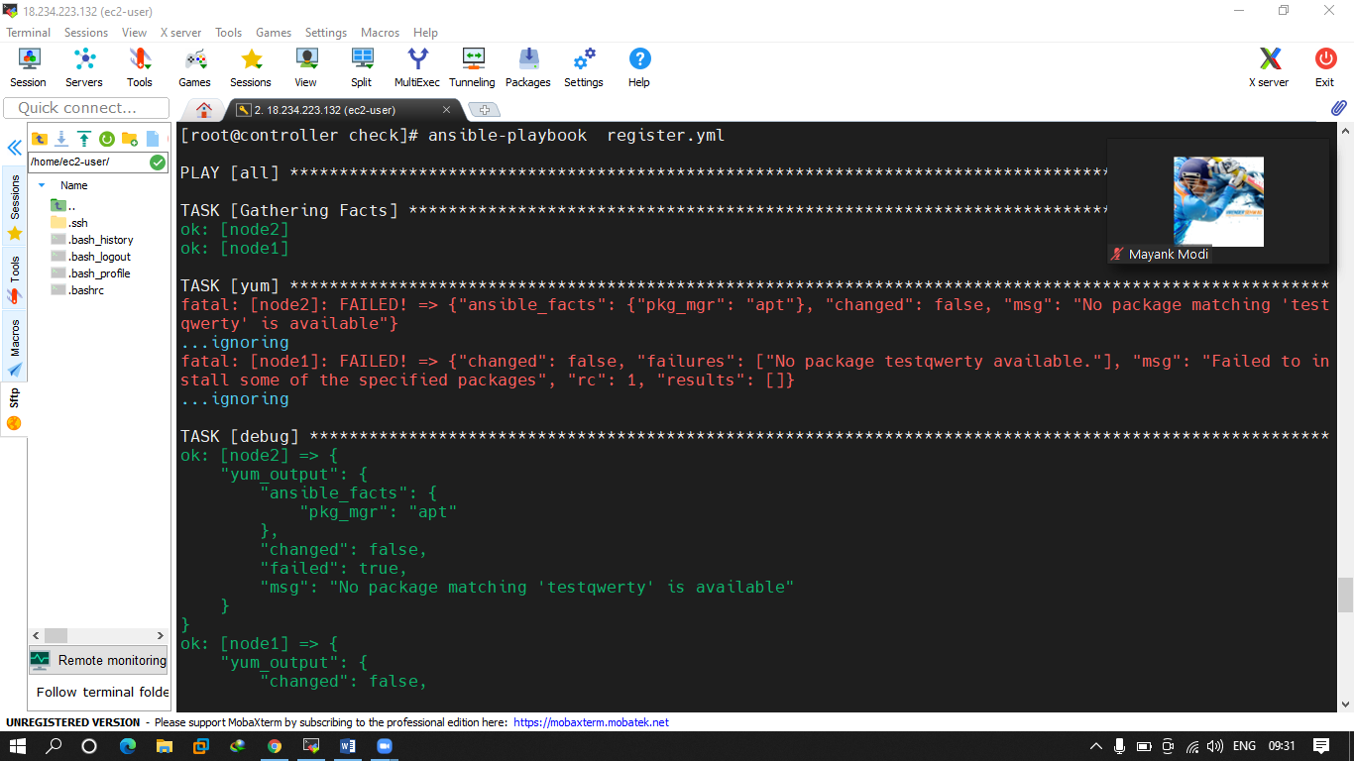

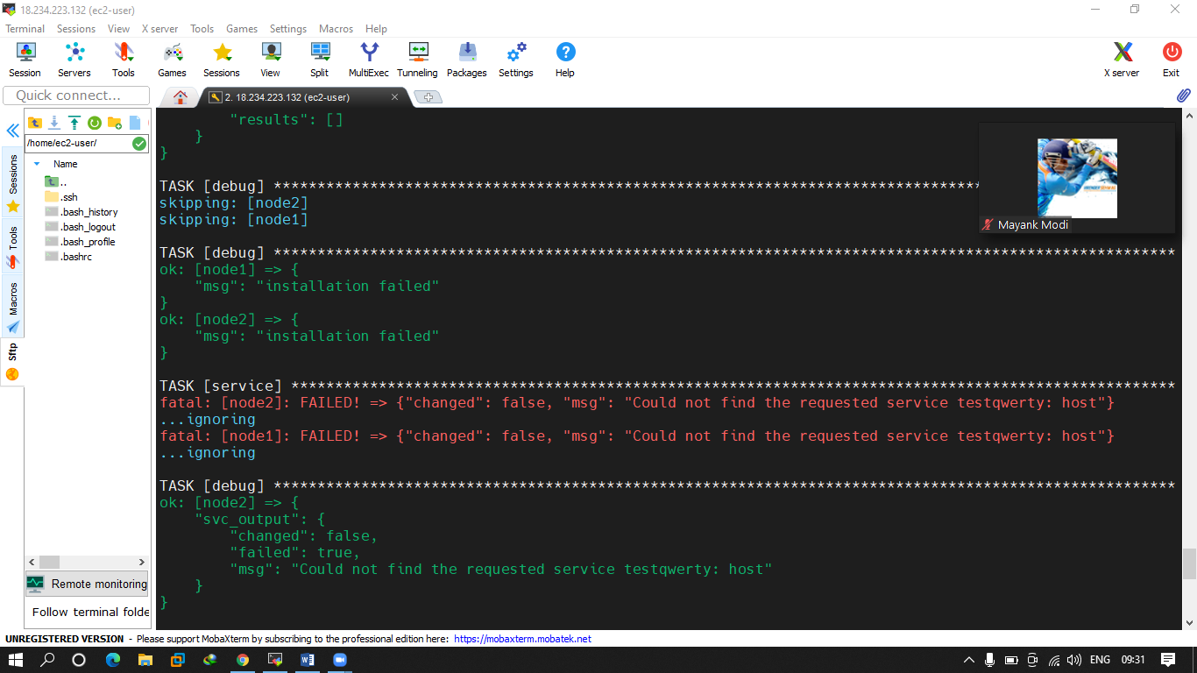

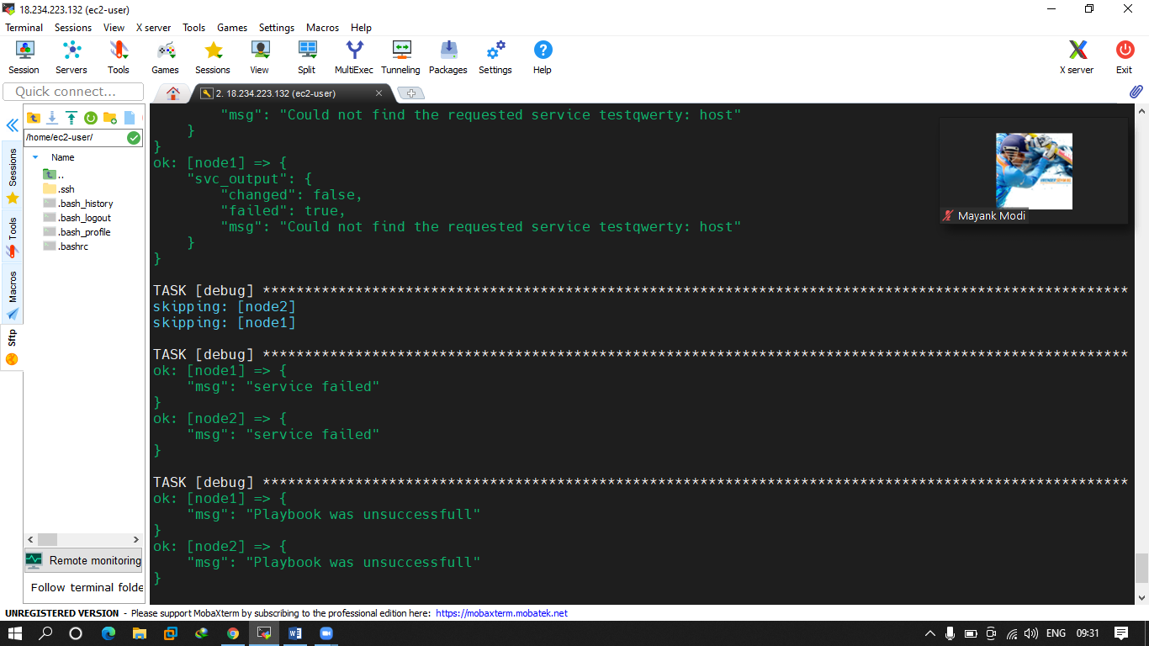

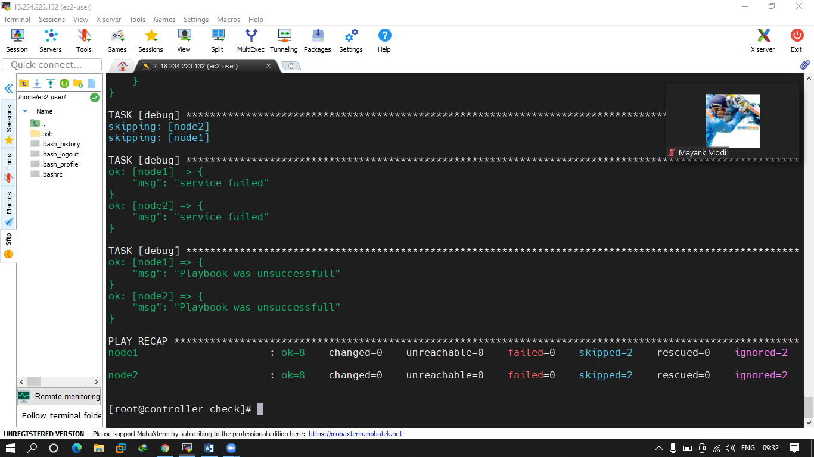

Q.2 try to create local dns file in location /etc/new.hosts in which

Ip hostname fqdn should be there for all machines.

* + - 1. node1 node1.example.com like this use template

ans. 2

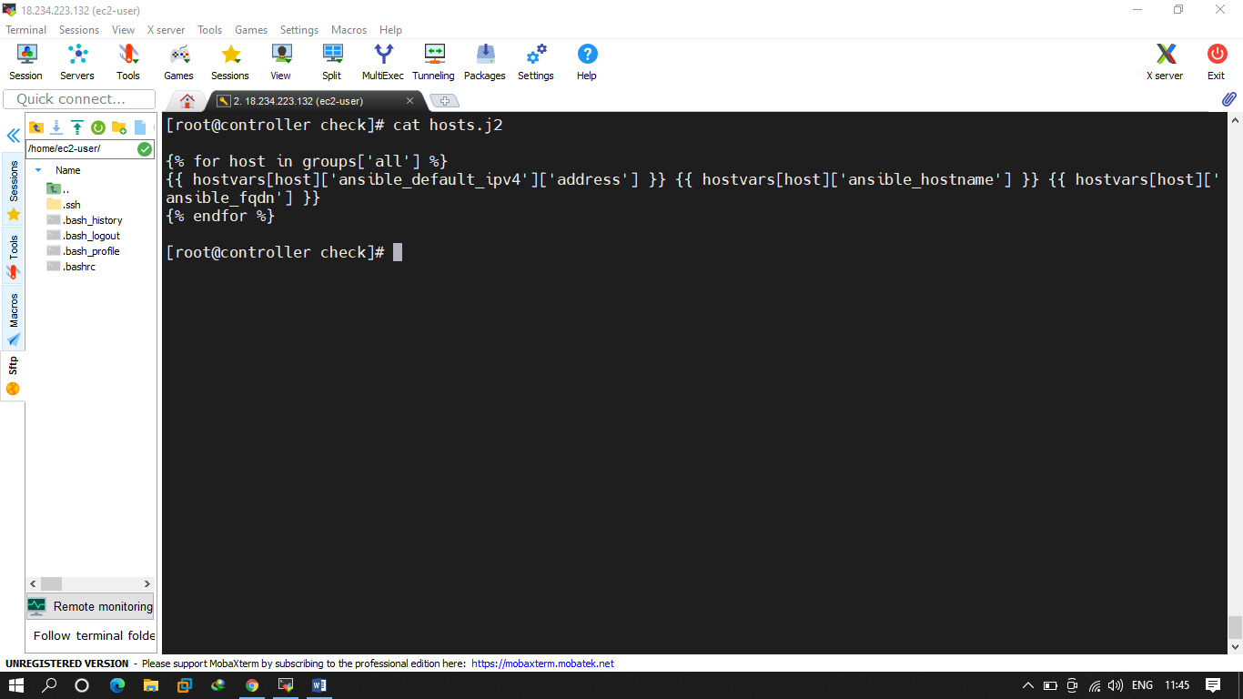

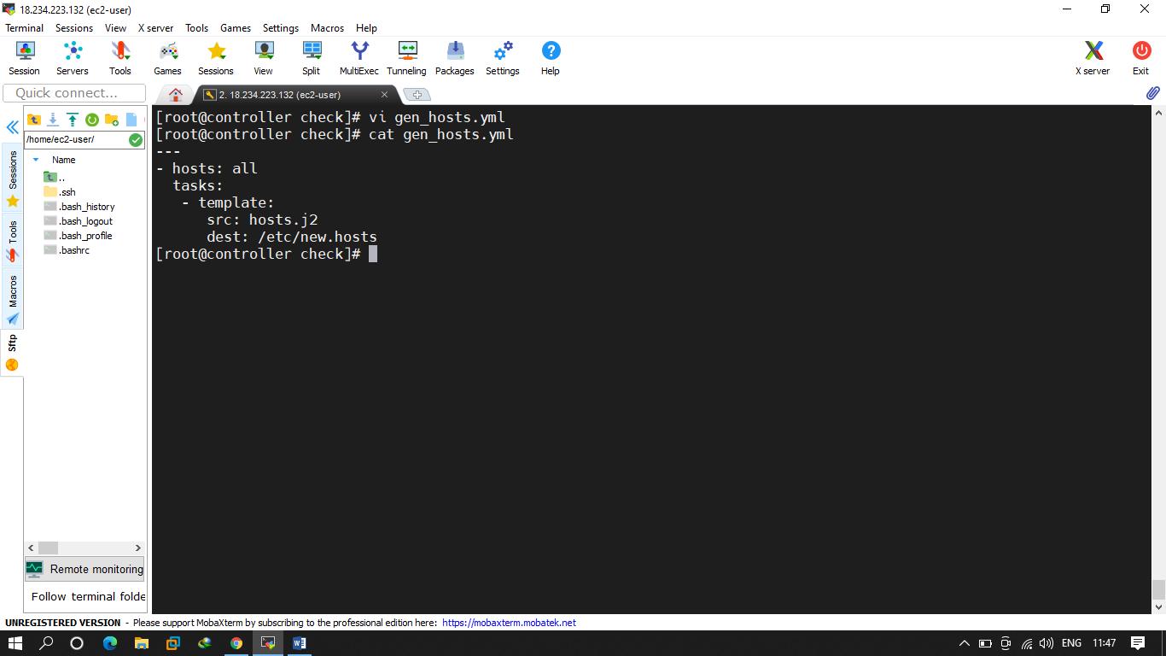

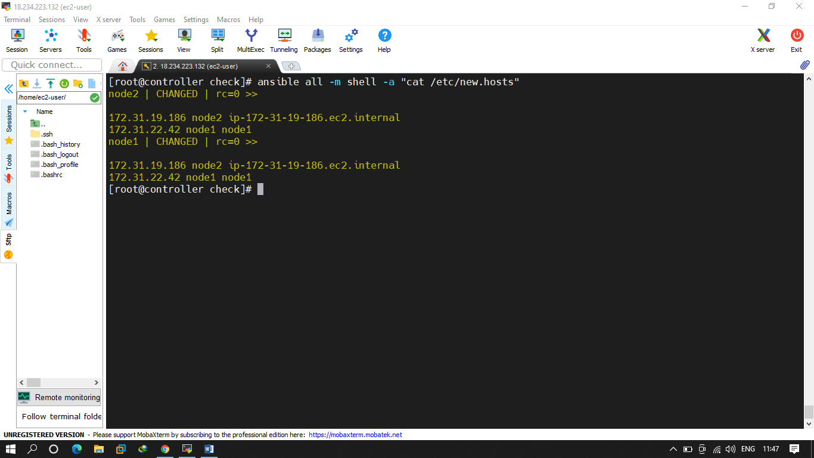

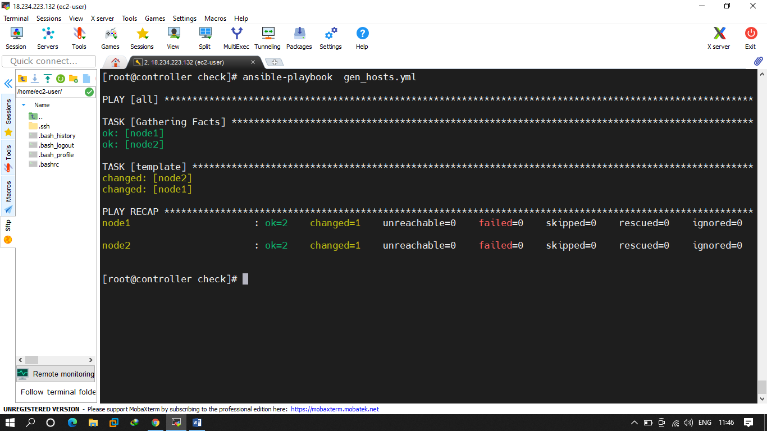

q.3 Try to configure a role that will configure your apache in both machines Ubuntu and redhat

conent should be anything using variables like hostname ip . use vars dir. For setting up the variables.

Ans. 2

Ansible-galaxy init mdhack0316.newroles

